WWW.VUTUBE.EDU.PK

ECO402 Microeconomics
Final Term Examination –

Question No. 1
Mar
ks :1

Economies of scale and economies of scope are synonymous. ~ True

~ False

Q uestion No. 2

Mar
ks : 1

Refer to the graph below. The marginal revenue curve is represented by curve:
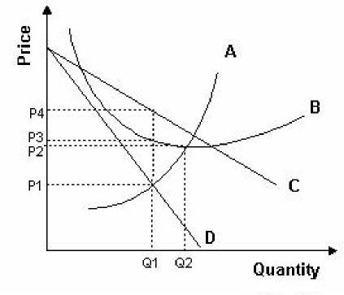
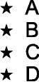

Q1uestinNo3.
Mar
ks :
ECO402 Final term

Government intervention without market failure creates .

If the market supply of labor increased relative to demand (baby boomers or female ee ntry), a surplus of labor would exist and the wage rate would: ~~ Fall
~~ Rise

- No effect
- All of the given options

Q uestion No. 5
Mar
ks : 3

State the main consequence of product differentiation? Write down the characteristics o f monopolistic competition.

Q uestion No. 6
Mar
ks : 1

Diminishing returns to labor occur at the______________ unit of input:
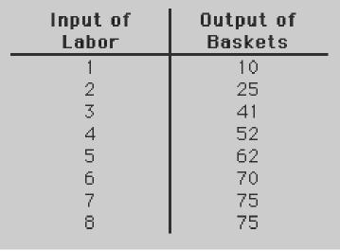

- 7th

- 2nd

- 5th
4
t_{h}
~

Question No. 7

Mar
ks : 1

Monopoly can charge any price that it wishes regardless to the market trend or the demand for the good.

- True
ECO402 Final term

- False

Q uestion No. 8
Mar
ks : 1

The short run supply curve of a monopolist is:

- The rising portion of the MC curve,
- The rising portion of the MC curve above AVC,
- The rising portion of the MC curve above AC,

~ None of the given option.

Q uestion No. 9
Mar
ks : 1

.

T otal profit= Total revenue

Q uestion No. 10
Mar
ks : 1

Opportunity cost, most broadly defined, is:

- The additional cost of producing an additional unit of output,

- What we forgo, or give up, when we make a choice or a decision,

- A cost that cannot be avoided, regardless of what is done in the future,

- The additional cost of buying an additional unit of a product,

Que stion No. 11 | M
arks :
1 0

Define oligopoly. How oligopoly market equilibrium is different from perfect competition and monopolistic com petition?

How is oligopoly different from?

- Perfect competition?

- Monopolistic competition?
- Monopoly?

Q uestion No. 12
Mar
ks : 1

The MRP for firms with market power is equal to:

 |  | ECO402 Final term
• | MP x W
• | MP x MR
• | MP x P
• | MP x MC
Qu estion No. 13 |  | M
arks :
3

D efine price discrimination. Why 1st degree price discrimination is practically

difficult?

Q uestion No. 14
Mar
ks : 1

Which of the following characteristics is common to both perfect competition and monopolistic competition?
- Average total cost is minimized in the long run.
- Marginal revenue equals price.

- Economic profits are zero in the long run.

- Price equals marginal cost.

The price of a good is $100, and the marginal cost of the good is $90. A competitive firm should produce that unit.
- True

- False

Question No. 16

Mar
ks : 1

Slope of total revenue is _______________ .

Question No. 17

Mar
ks : 1

One characteristic often seen in real world oligopolies is:
- Fluctuating prices.
- Zero economic profit.

- Low barriers to entry.

- Price rigidity.

Question No. 18
Mar
ks : 3

ECO402 Final term

What type of difference is shown by economic rent?

Question No. 19
Mar
ks : 1

Different combinations of labor and capital that have the same total costs can be shown by a(n):
- Isoquant line

- Isocost line

- Production function.
- Total cost curve.

Question No. 20

Mar
ks : 1

In an oligopoly, there are only a few firms and a firm can control price, regardless of the actions of other firms in the industry.

- True

- False

Question No. 21
Mar
ks : 1

If factor prices rise as industry output expands in the long run, we have:

- A constant-cost industry,

- A decreasing-cost industry,

- An increasing cost industry,
- Any of the given option

The difference between what consumer is willing to pay for an item and what he actually pays is called _______ .

Question No. 23
Mar
ks : 1

Demand for a product is elastic when:

- A fall in the price of the product causes total expenditures by consumers on the product to fall

- The percentage change in quantity demanded equals the percentage change in price.

- Total expenditures by consumers for the product increase when the product's price falls.

- A fall in the price of the product does not affect the firm's revenue.
ECO402 Final term

Question No. 24 Marks : 10

Use the table below to answer the following questions.

# of | Total Product | Marginal | Average
Workers |  | Product | Product
per day
0 | 0
1 | 4

2 10

3 18

4 22

5 24

6 22

- Fill in the table above.

- At what point (number of workers) does the firm experience diminishing returns? Explain.

Question No. 25
Mar
ks : 1

The total variable costs of producing no output are:
- 0
- 100
- 400
- Incalculable from the information given in this question.

Differentiate between Natural monopoly and artificial monopoly?

Question No. 27
Mar
ks : 1
ECO402 Final term

Who lose from import quotas?

- Consumers of imported goods.

- Consumers of exported goods.
- Producers of imported goods.

- Firms that hold import licenses.

Question No. 28

Mar
ks : 1

OPEC is best example of cartel:

- True

- false

Question No. 29
Mar
ks : 1

measures the percentage change in quantity demanded resulting from a one percent change in income.

Question No. 30
Mar
ks : 1

A monopsony is a situation where there is a (n):

- Single buyer.

- Single seller.

- Oligopoly.
- Competitor with a monopolist.

Question No. 31
Mar
ks : 3

Differentiate between import tariff and import quotas?

Question No. 32
Mar
ks : 1

and

The general shape of the marginal cost curve is that it then :

- is horizontal, declines
ECO402 Final term

- is horizontal, rises
- rises, declines
- declines, rises

